Problem Statement

You are working as a AzureML engineer in Zendrix Software Pvt Ltd. The data science team in the company has created data-set. Analyzing this data-set can help boost business.

The data-set is provided in portal along with this assignment.

The company wants you to train this data set and deploy the best ML model using Azure ML tools.

Following are the tasks which are expected:

1. Go to Azure Portal. Create Machine Learning Space to use Azure Machine Learning Model.
2. Upload Bank_Marketing data-set (provided).
3. Train the uploaded data-set using Azure Automated ML.
4. Finally, create a pipeline to run the model.

# Infrastructure Requirements

Azure Account and a workspace to launch your Azure ML Studio.

Steps Followed.

1.Dataset -Bank created in workspace

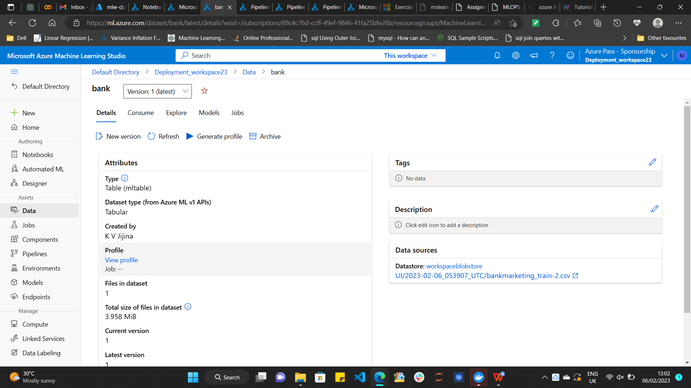

1. Compute Created

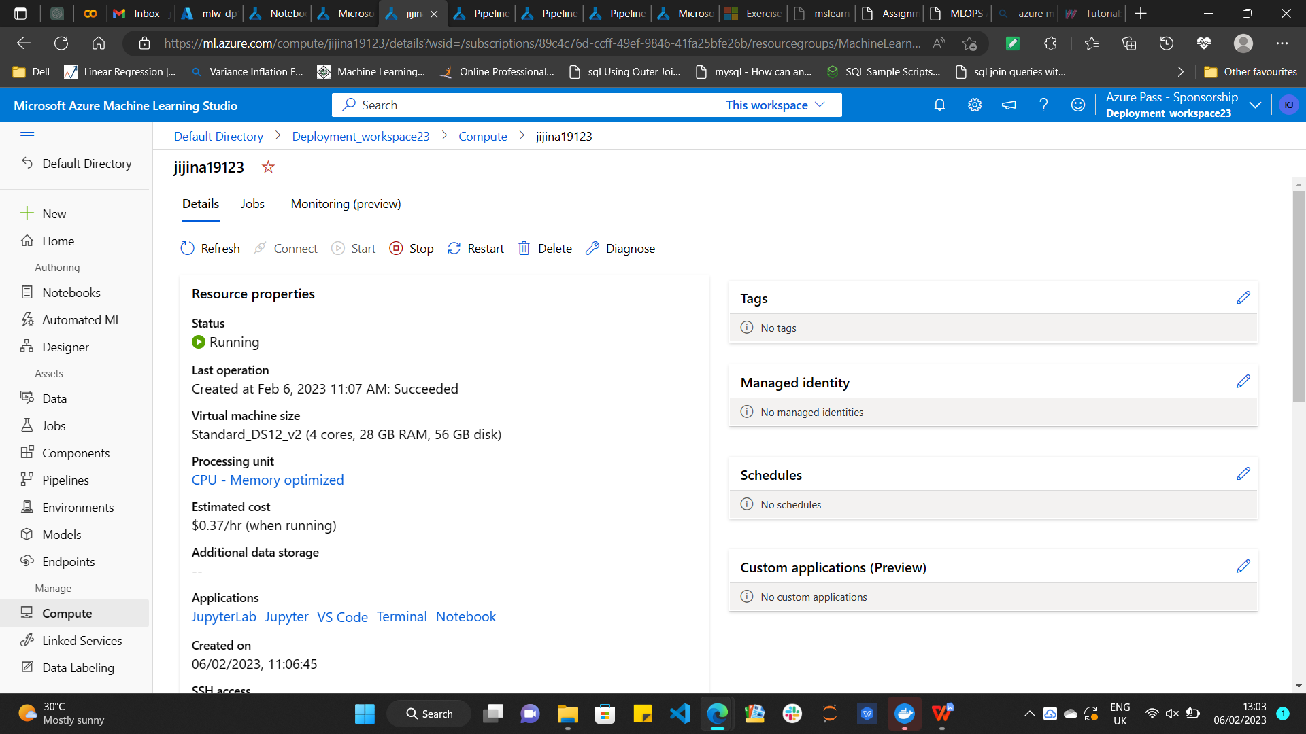

1. Best model created using Automated ML

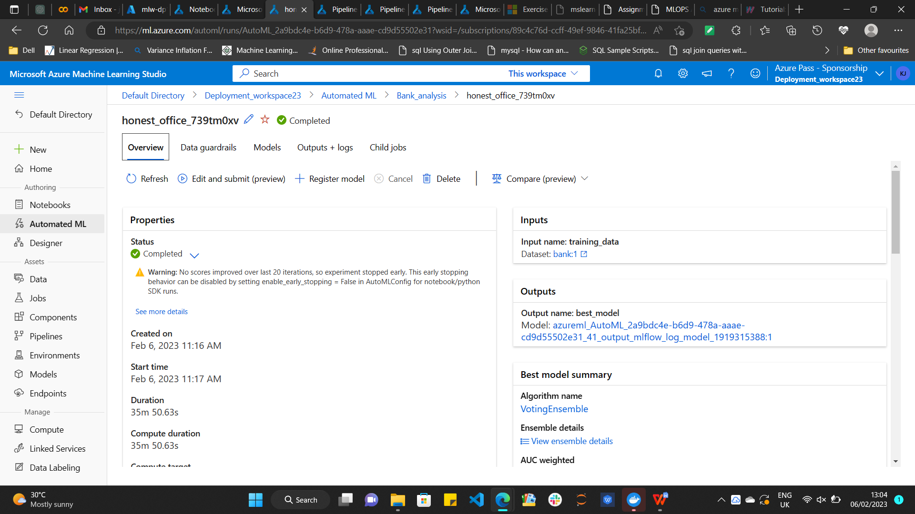

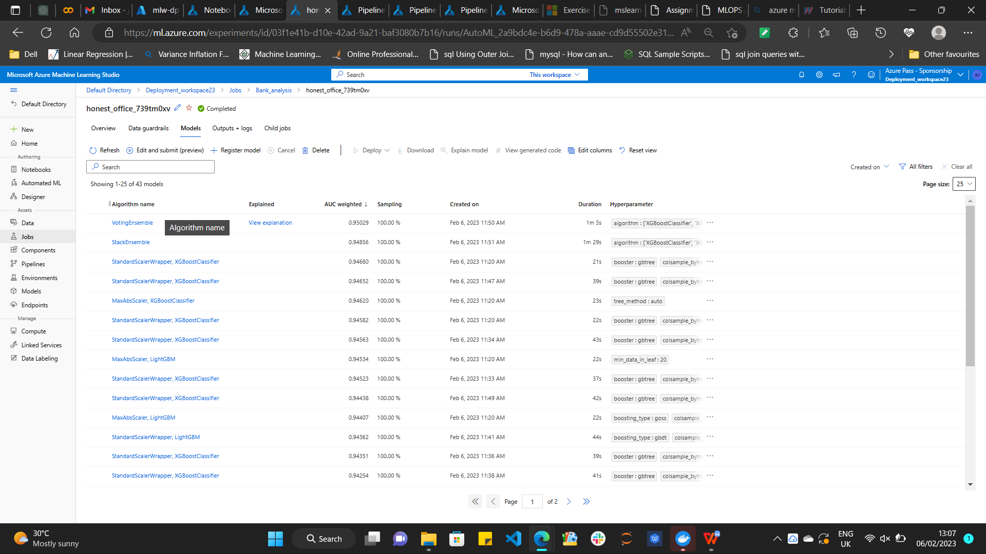

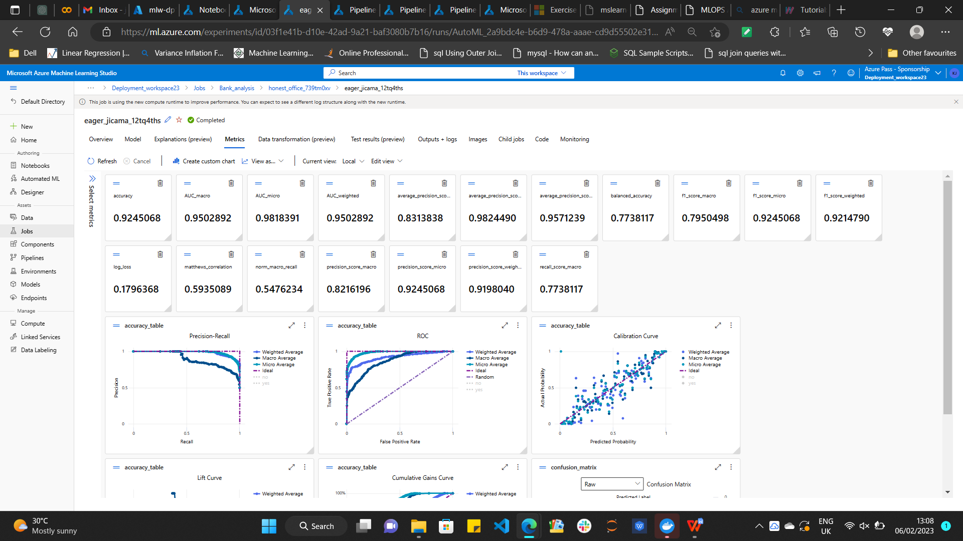

1. Pipeline Created

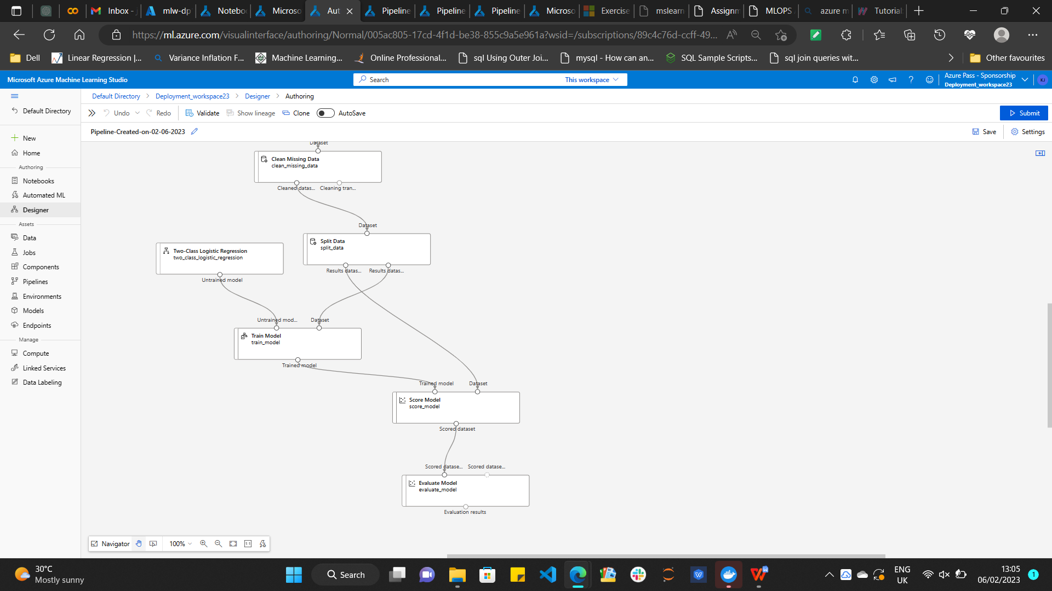

1. Real time inference pipeline created and deployed

